Governor Asa Hutchinson Buffalo River Watershed Alliance
State Capitol National Parks Conservation Asso.
500 Woodlane Street Arkansas Canoe Club
Suite 250 PO Box 101
Little Rock, AR 72201 Jasper, AR 72641

May 15, 2015

Dear Governor Hutchinson,

Thank you for prompt reply to our letter. It is reassuring to our thousands of coalition members (and hundreds-of-thousands of fellow Arkansans) that you share our concern over the future of our National River. The proximity of the Cargill sponsored factory hog farm to the Buffalo and the karst geology of the area is certainly problematic. The past Director of the Arkansas Department of Environmental Quality Teresa Marks, who approved the C & H Farm permit, was quoted in the New York Times as saying that pollution to the Buffalo is probable.

We agree with you that the situation needs monitoring and any future action be based on “science and fact”. In your letter, you pointed to the University of Arkansas “Big Creek Study”. You may not be aware, but the study is not monitoring the spray fields that will receive the largest amount of feces and urine. Also, the study’s primary focus is gauging surface run-off rather than what is happening to untreated sewage once it seeps through the porous limestone rock and into the groundwater.

There are other studies underway. Since 1985, the National Park Service has been monitoring dozens of tributaries, springs, and river sites for pollutants including E. coli. This past year, NPS saw a dramatic increase in E. coli in Big Creek downstream from C & H Hog Farm. In fact, the levels were beyond the recreational contact limit for two months. Elevated E. coli readings were also found below its confluence with the Buffalo, but not above it.

Besides the Park Service, nationally known hydrogeologist Dr. Van Brahana, also a professor at the University of Arkansas, has been independently mapping underground water ways and testing neighboring wells for almost two years. In addition, a federal court mandated Environmental Assessment is soon to begin. The new EA is to replace the flawed and inadequate report that was originally submitted on behalf of C & H Farms to qualify for a taxpayer subsidized loan guarantee from the Small Business Administration and the Farm Service Agency.

Governor Hutchinson, when considering the future of the factory hog farm we ask that you also take into consideration these other studies while making any decisions.

Again, thank you for your prompt response and your concerns,

Sincerely,

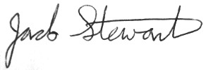
Jack Stewart
Buffalo River Watershed Alliance

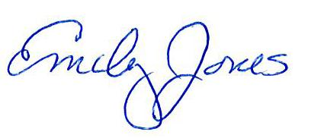
Emily Jones
National Parks Conservation Association

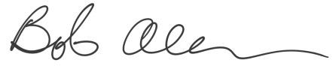
Bob Allen
Arkansas Canoe Club

